ZRT-1601-G1 Single-Shaft Automatic Cutting Machine
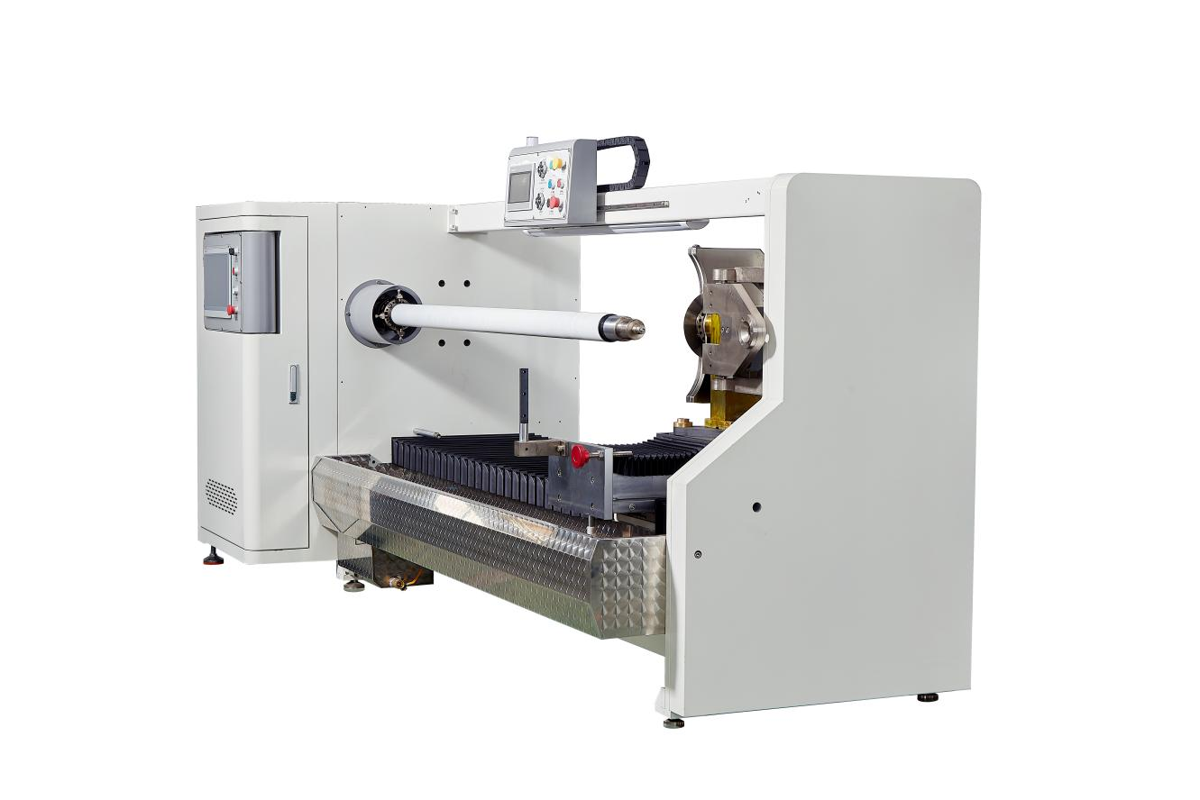
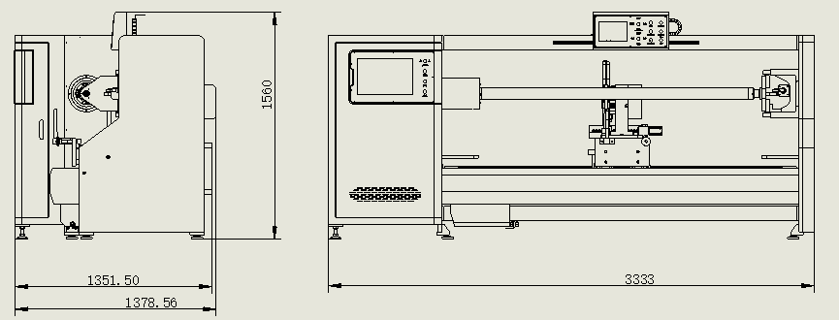
Equipment layout：
Basic Use：
Mainly used for cutting of gold fingers, electronic films, PE, TPU, PET, kraft paper, and paper tape, bopp, tape, and acrylic tape, etc.
Equipment Advantages：
- Heikawa Motion Control System offers 12 different modes for cutting products of various widths. Users can freely select from the starting row to the ending row. It also features three different feed speeds for cutting the products.
- The main shaft is controlled by 5000W servo, and the circular cutter is controlled by 3300W servo. The advantages are: the machine will stop immediately upon an alarm to prevent the cutter from breaking.
- The horizontal movement is achieved using an NSK 3210 lead screw and 30 guide rails, with 1500W servo control. This ensures a positional accuracy within 1000mm with a tolerance of ±0.02.
- The feed mechanism adopts an upper silver 3210 screw and 30 guide rails, with 1500W servo control, ensuring the strength and accuracy of the feed.
- The swing angle is equipped with an upper silver 1610 screw rod and 400W servo control. The maximum angle is +9.5° and the minimum angle is -9.5°.
- The cooling process uses a 60W water pump, and the precise ball valve is used to regulate the water volume, achieving silent cooling.
- The knife holder and the lateral movement processing have undergone QBQ treatment, which enhances the hardness, wear resistance, corrosion resistance and deformation resistance of the parts.
- Dual screens are adopted: The main screen is a 15-inch display, and the auxiliary screen is a 7-inch one. The operation is simple and clear.
- Overall machine lighting: Lighting for opening the electrical box, photos of opening the machine box, and lighting for the startup operation.
- The knife box is designed as a dry-wet separation type. The cutting silicone oil is absorbed by the sponge in the wet area, and the dry area is wiped clean with wool felt to remove any residual silicone oil from the blade, thereby reducing the amount of silicone oil remaining on the material.
- Drainage system: Designed as a diversion pipe for drainage, so there will be no silicone oil everywhere during operation.
Main Technical Parameters：
Name/Model | ZRT-1601-G1
paper core | Customized according to customer requirements (can be freely replaced) 38/50/76
Cutting width | 0.5-1600mm
Maximum cutting diameter | 320mm
The maximum diameter of the shearing blade | 400mm
Dual-screen control | 15inch 7inch
power supply | 380V（Customizable 220V） 50/60HZ/13KW
air pressure | 5KG
Machine size | L3400mm*W1600mm*H1400mm
Net Weight | 1.5 T

Configuration Parameters
Model | SCT-1601-G1
touch screen | 15inch HCFA
Auxiliary touch screen | 7inch HCFA
Rack wall panel | 28mm
Motion controller | HCFA
Spindle servo motor | 5000W HCFA
Spindle servo driver | 5000W HCFA
Circular knife servo motor | 3000W HCFA
Circular knife drive | 3000W HCFA
Lateral servo motor | 1500W HCFA
Lateral servo driver | 1500W HCFA
Feed servo motor | 1500W HCFA
Feed servo drive | 1500W HCFA
Angle positioning servo | 400W HCFA
Angle positioning servo drive | 400W HCFA
Water pump | 60W
Planetary reducer | Smetre
Air switch | chint
Switching power supply | Mingwei
Photoelectric sensor | BOJKE
Proximity switch | Yangming
AC contactor | Schneider
Relay | IDEA
Button switch | Schneider
Three-color warning light | TAYB
illumination | LED
Solenoid valve | Asicko
Air cylinder | AIRTAC
Linear rail | HIWIN
Magnet switch | AIRTAC
Spindle 3 inches | Taiwan
Bearing | NSK
Fuselage | Lmported paint finish
Circular knife | MAX 400mm
Work-box | 1 set
Dialgage | 1 set
The tool post | 1PCS

